CYB 240 Module One Lab Worksheet
Andree Salvo
Southern New Hampshire University
CYB 240-13711
Instuctor: Brian Remson

Prompt | Response
In the lab section “Reviewing HTML From a Pentester’s Perspective,” Step 6, provide a screenshot of the HTML code and login page before closing the window. | 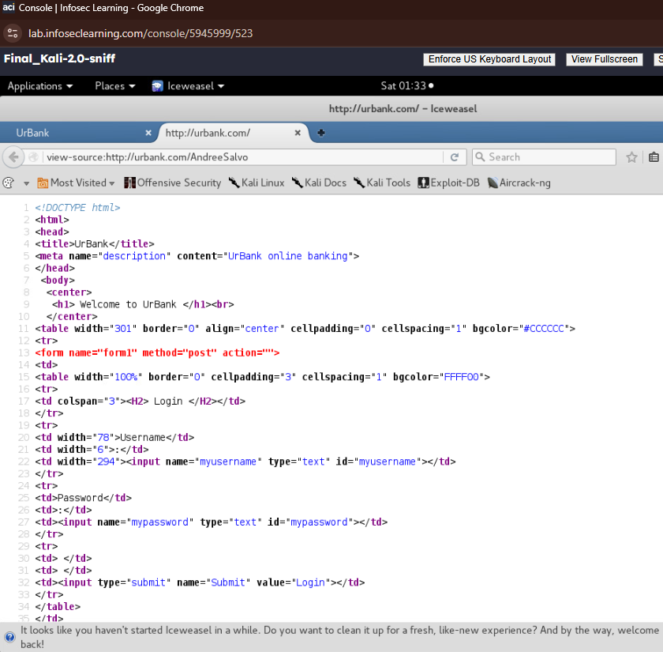  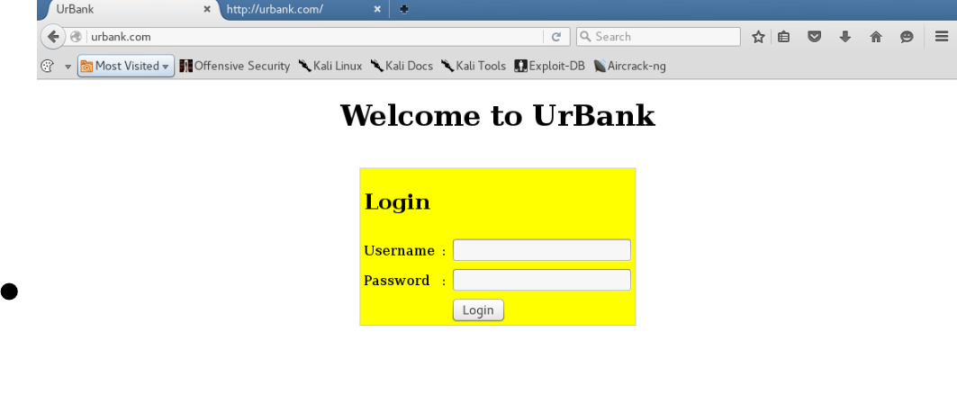
There is a fundamental difference between HTML and xHTML. What rules were applied to xHTML that are not needed for HTML, and why were those rules put in place? | Rules:  • Empty elements must be self-closed (<br />, <input />).  • Attribute values must be enclosed in double quotes.  • Tag and attribute names must be in lowercase.  • The document must begin with an XHTML DOCTYPE.  • The <html> tag must include the XML namespace.  • The document must be well-formed XML.  Explanation:  These rules were added because XHTML follows XML, which is a lot stricter than regular HTML. They help keep code clean, make it easier for computers to read, and prevent weird display issues in different browsers.

